**Sports Medicine Outline for Week**

*The following outline provides you with a central theme for the day and some all important questions!*

**Topic 1: Overview of Sports Medicine with some all-important Anatomy!**

* + What is Sports Medicine?
  + What types of Careers are associated with Sports Medicine?
  + Why do many Specialists believe that understanding Basic Anatomy is considered to be the “Holy Grail” in this field?
  + What is meant by the term “Assessment”? How does this help to solve the pieces of the puzzle when an athlete is hurt and needs to get “back in the game?”

**Topic 2: Rehabilitation, Injury prevention, and the role of Exercise!**

* + What are the 3 phases of care an athlete needs after an injury occurs?
  + Why is it so important to start care immediately following an injury?
  + What specific role does exercise play when treating an injury?
  + What is the difference between strength training, flexibility, and agility?

**Topic 3: Peak Sports Performance: “Fitness” Testing and Conditioning**

What does it mean to be “fit?”

Is it necessary to be fit to excel?

What are the latest fitness tests?

What is BMI and body fat and what how does it relate to fitness?

**Topic 4: Nutrition Science, Sports Supplements & PED’s!**

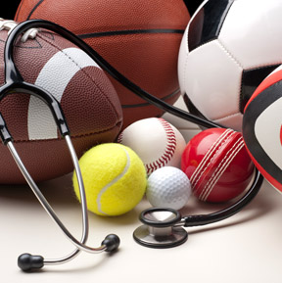

* What kinds of foods should the athlete for peak performance?
* What is the importance of hydration?
* Do supplements help athletes and are they safe?
* What are PED’s and what’s all the hype?

**Topic I: Overview of Sports Medicine with that all important Anatomy!**

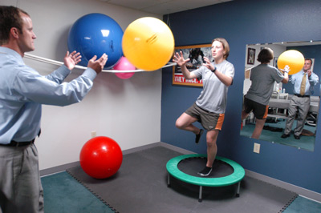

1. **What is Sports Medicine?**

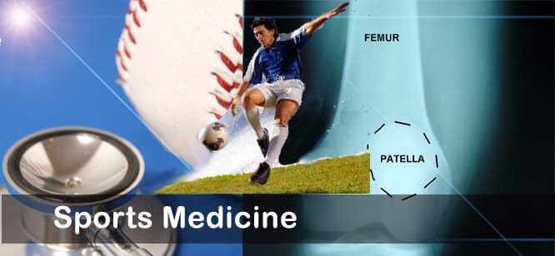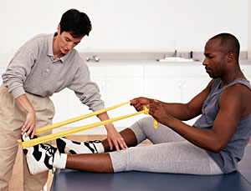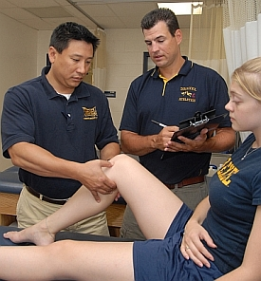

**Look at the preceding pictures and briefly write in one short paragraph what you think Sports Medicine is?**

**__________________________________________________________________**

**__________________________________________________________________**

**__________________________________________________________________**

**__________________________________________________________________**

**__________________________________________________________________**

**__________________________________________________________________**

**__________________________________________________________________**

1. **What types of careers are associated with Sports Medicine?**

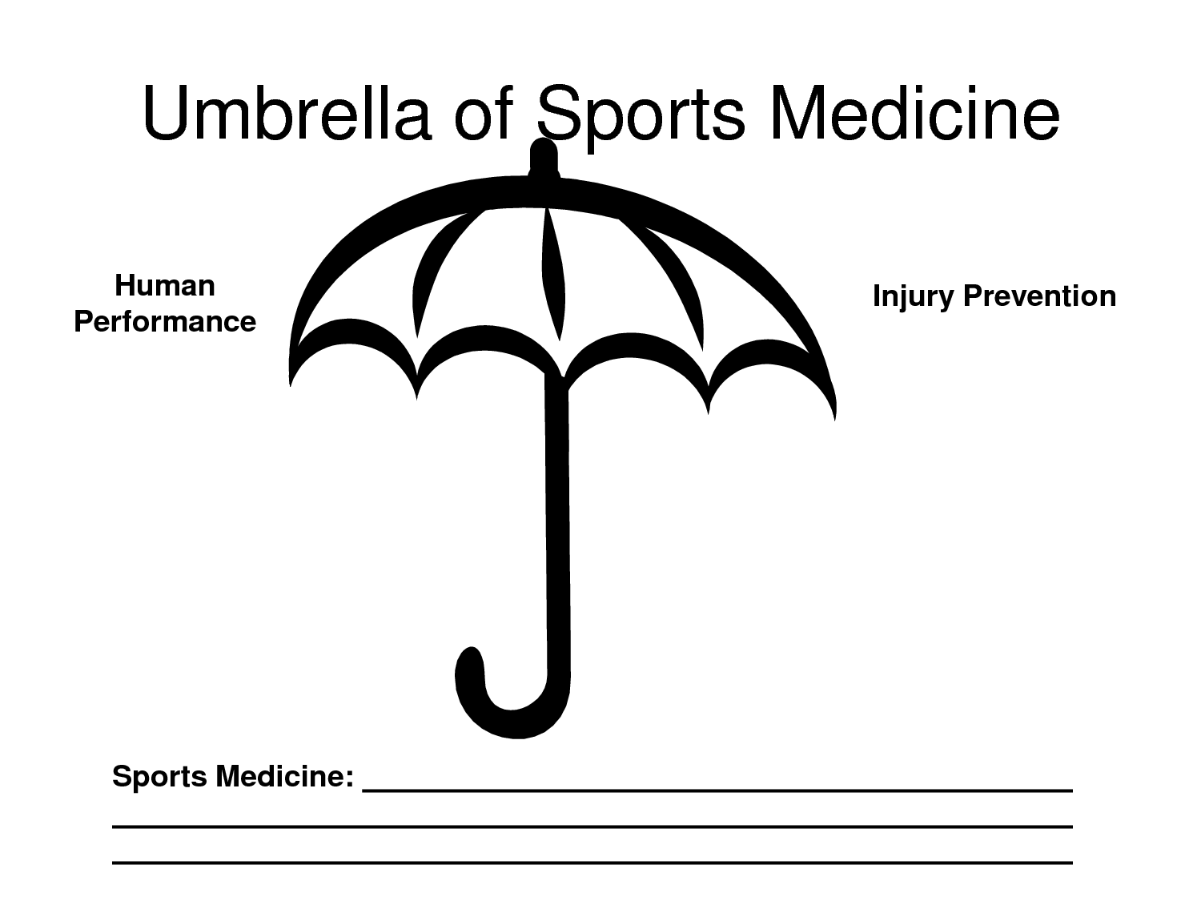

**List below what types of careers an individual can go into that incorporate Sports medicine?**

**__________________________________________________________________**

**__________________________________________________________________**

**__________________________________________________________________**

**__________________________________________________________________**

**__________________________________________________________________**

**__________________________________________________________________**

**__________________________________________________________________**

**III. Clinical Anatomy as it relates to Sports Medicine –The “Holy Grail”**

The key to any study of Medicine- including Sports Medicine- is understanding Anatomy and how it applies to movement, health, and injury. We will study some key muscles and understand their actions in the upper body, lower body, abdominal and spinal region. This is just a cursory overview, but will give you an appreciation of “Clinical Anatomy”. Many Health care practitioners will suggest that Clinical Anatomy is the Hallmark of Medicine- including Sports Medicine.

Before we learn some basic Anatomy it is important to understand “direction” as it applies to movement. When we move a body part such as an arm or leg it is going through a particular “plane” of motion. No different than a plane that goes North or West, or Northwest, or Southeast. For instance, if you pick up a box and place it on a table in front of you, you are using your biceps and you are flexing them in a sagittal plane. Let’s looks at the chart below and learn our planes of motion

Coronal Plane (Aka- Frontal)

Sagittal Plane

Transverse Plane (Aka- Horizontal)

**Mini Lab: Students will partner up in anatomical position and list the Planes of motion to each other as well as directional terms.**

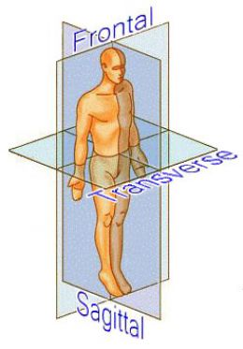

**Now, let’s examine the various directions of the human body as it relates to the anatomical position.**

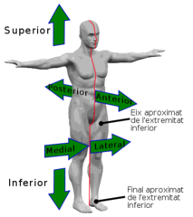

**Directional Terms:**

1. Anatomical Position- the body is standing, facing forward, and palms forward

2. Superior – Towards the head end of the body; above.

3. Inferior – Away from the head end of the body; lower.

4. Anterior (Ventral) – Front

5. Posterior (Dorsal) – Back

6. Medial- Toward the midline of the body

7. Lateral – Away from the midline of the body

8. Proximal – Nearer the point of attachment of an extremity to the trunk or the point of origin of a part.

9. Distal – Farther from the point of attachment of an extremity to the trunk or the point of origin of a part

**Now that you have learned the Planes of Motion and directions- why do you think symmetry of motion is important in sports performance and injury prevention?**

**__________________________________________________________________**

**__________________________________________________________________**

**__________________________________________________________________**

**__________________________________________________________________**

**__________________________________________________________________**

**__________________________________________________________________**

Below is a list of KEY power muscles! Your job is to identify it on the Anatomy chart, identify **region on body**, and state the Action of that muscle and on what body part.

**Muscle Region on Body Action**

Bicep

Triceps

Deltoid

Latissimus Dorsi

Trapezius

Pectoralis Major

Rotator Cuff

Wrist flexors

Wrist extensors

Rectus Abdominus

Obliques

**Muscle** **Region of Body** **Action**

Erectors spinae

Quadriceps

Hamstrings

Gastrocnemius

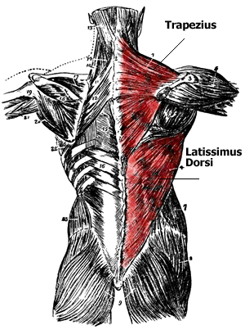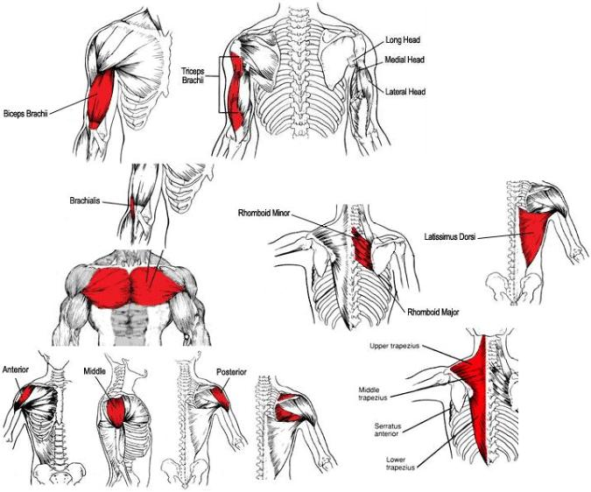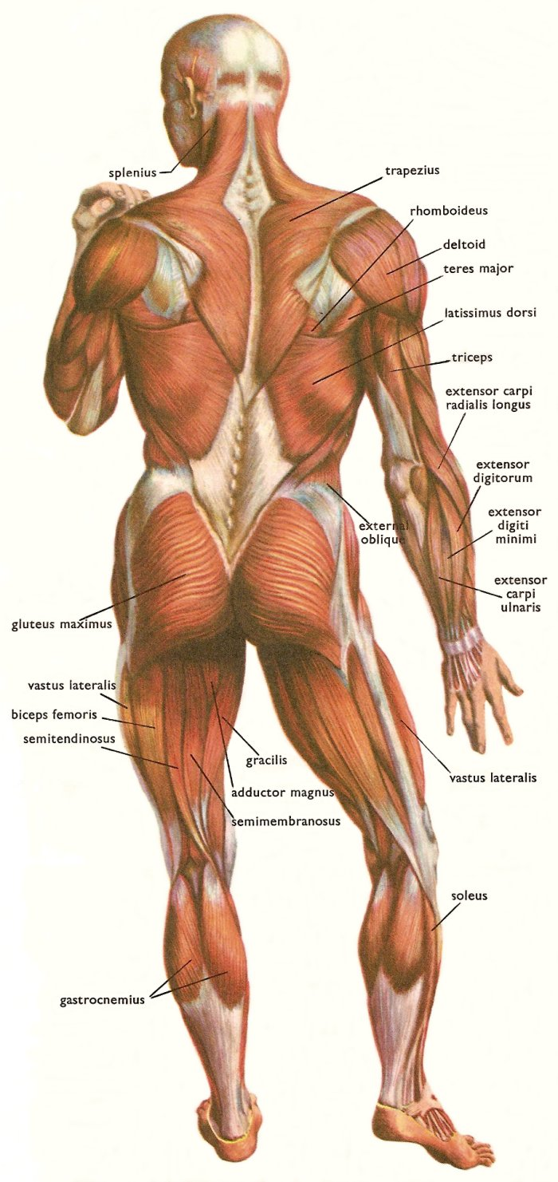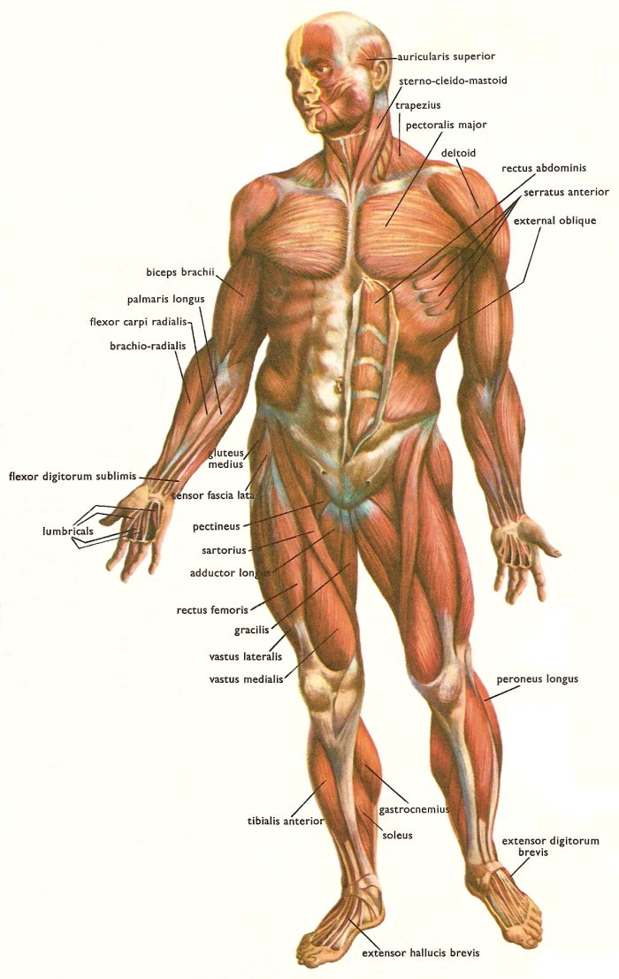

**IV. What happens when an athlete is injured and needs to get back in the “game”? How does a Sports Medicine practitioner go about assessing the injury?**

Before we get into assessing injuries it is important to list some significant injuries that an athlete may encounter. Remember, we are not just talking about the very competitive athlete on the Professional, Collegiate, or high school level- but also the weekend warrior, or even the occasional recreational athlete.

Injuries can occur anytime and anyplace, and in any activity- From football, wrestling, soccer, tennis, baseball, basketball, track & field, badminton, lacrosse, golf, and table tennis!

Prevention First

Worried about sports injuries? Don't sweat it. Think of avoiding injury as just another part of playing by the rules — only this rulebook is the one that keeps you from getting hurt. That's because the best way to deal with sports injuries is to prevent them. Prevention includes knowing the rules of the game you're playing, using the proper equipment, and playing it safe.

But you've practiced with your team, played it safe on the field, and still sustained an injury. Don't worry, it's not the end of the world — just the beginning of a healing process. Read on to find out what this process is and how you can deal with a sports injury.

What Are Sports Injuries?

There are **two general types**. The first type is an________________________. This injury usually involve a single blow from a single application of force — like getting a cross-body block in football.

Acute traumatic injuries include:

•a fracture — ______________________________________________

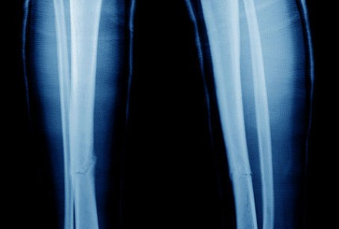

•a bruise, known medically as a _______________— caused by a direct blow, which may cause ______________and _______________in the soft tissue

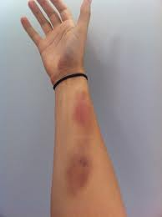

•a strain — a stretch or tear of a ___________________ ­­­­­­­­­­­­­­­­­­­or____________, the tough and narrow end of a muscle that connects it to a bone

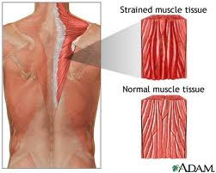

•a sprain — a stretch or tear of a__________________, the tissue that supports and strengthens joints by connecting bones and cartilage

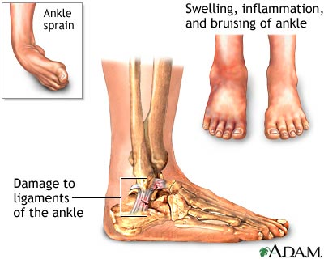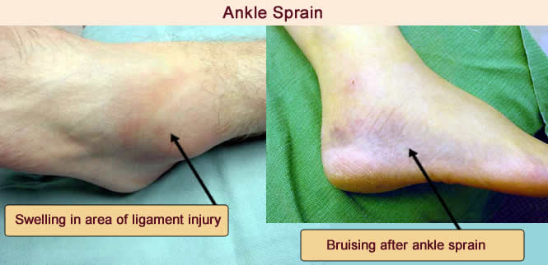

*an abrasion — a _________________

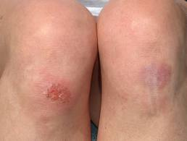

•a laceration — a cut in the skin that is usually deep enough to require _________________

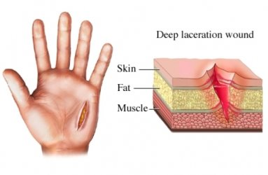

The second type of sports injury is an overuse or chronic injury. Chronic injuries are those that happen over a period of time. Chronic injuries are usually the result of ____________________training, such as running, overhand throwing, or serving a ball in tennis. Repetitive injuries are by far and away the ___________ ___________________ form of injury in all sports!

**Chronic Overuse or Repetitive Stress injuries**

•stress fractures — tiny cracks in the ______________ surface often caused by repetitive _________________(such as in the feet of a basketball player who is continuously jumping on the court)

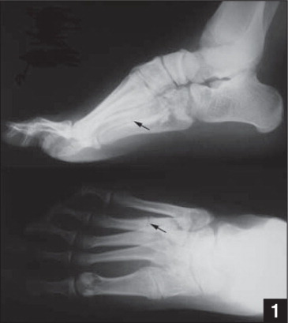

•tendonitis —______________________of the tendon caused by repetitive stretching

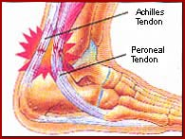

•epiphysitis or apophysitis — growth _______________overload injuries such as _______________________________disease

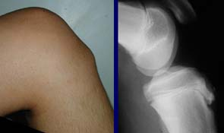

**Often overuse injuries seem less important than acute injuries. You may be tempted to ignore that aching in your wrist or that soreness in your knees, but always remember that just because an injury isn't dramatic doesn't mean it's unimportant or will go away on its own. If left untreated, a chronic injury will probably get worse over time.**

Once an Athlete is injured it is really important for the Sports Medicine Specialist to **“Assess**” the injured area. How will **YOU** assess the injury like the Pros?

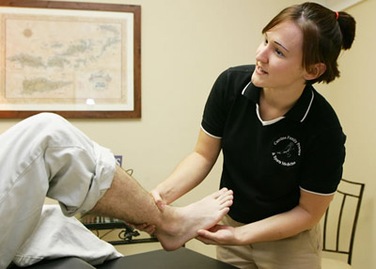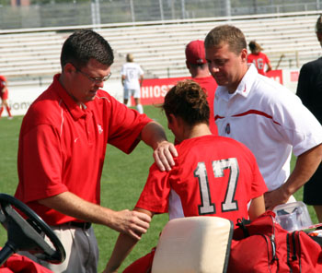

**What do we mean by “History” and what does that have to do with an athlete’s injury?**

_____________________________________________________________________________________

_____________________________________________________________________________________

_____________________________________________________________________________________

**After your brief “history” you must then perform and Observation- what will you be looking for in your observation?**

_____________________________________________________________________________________

_____________________________________________________________________________________

_____________________________________________________________________________________

**Next is the really fun part- YOU get to perform a “hands-on” assessment of your injured athlete!**

**Mini Lab**

**You will finish your assessment by evaluating your “patient-athlete” with some tools of the trade! Be prepared to test some muscles, nerves, tendons, ligaments, and joints! I will put you through a battery of tests and have you practice on each other.**

**After your mock exam I would like you to reflect on some of the tools and approaches to your exam. To be the best Sports Medicine Docs and therapist out there you better know the following definitions! Have fun!!**

**What does ROM stand for?**

_____________________________________________________________________________________

_____________________________________________________________________________________

**What possible injury could you detect from muscle testing?**

_____________________________________________________________________________________

_____________________________________________________________________________________

**What is the role of the reflex hammer and pinwheel?**

_____________________________________________________________________________________

_____________________________________________________________________________________

**What is a hand “dynamometer” and what could that possibly demonstrate?**

_____________________________________________________________________________________

_____________________________________________________________________________________

**After your assessment, why do you think some practitioners want or need to do additional testing? (i.e X-rays, MRI’s)**

_____________________________________________________________________________________

_____________________________________________________________________________________

**Video: Of assessment of shoulder injury for patient**

**Topic 2: Rehabilitation, Injury Prevention, and the Role of Exercise!**

Prevention is the #1 anecdote to containing and managing most injures. Oftentimes in sports the focus is the outcome and well intentioned coaches are focused on the results only. This is great and coaches and players should have that focus- to succeed at their sport and master their skill thereby contributing to overall success. Unfortunately most sport activities create imbalances within the body and these imbalances lead to the breakdown of tissues that are predominately overused.

Prehab is all about training the body to give it a better balance. It is breaking out of the old mold which centered on hammering the athletes in methods that were taught many years ago. There is a common sense approach to training the body in addition to sport specific training that will allow the athlete to potentially prevent an injury before it occurs.

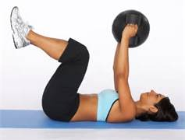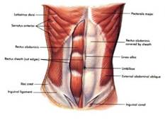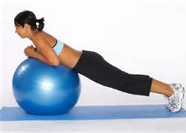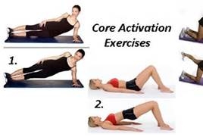

**Mini Lab**

**Take 10 minutes and go through a “Pre-hab” exercise routine: If you feel uncomfortable in any way please let the instructor know and do not continue with exercises.**

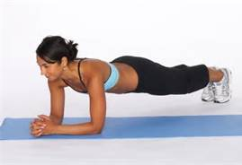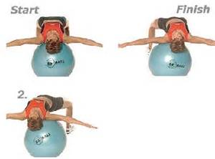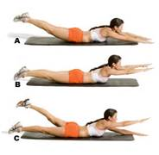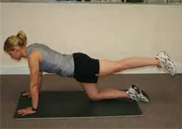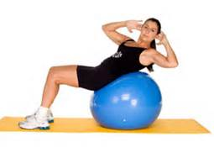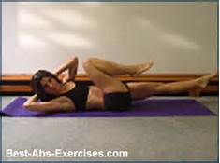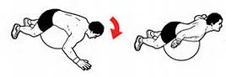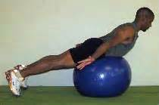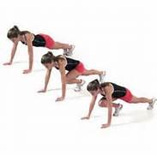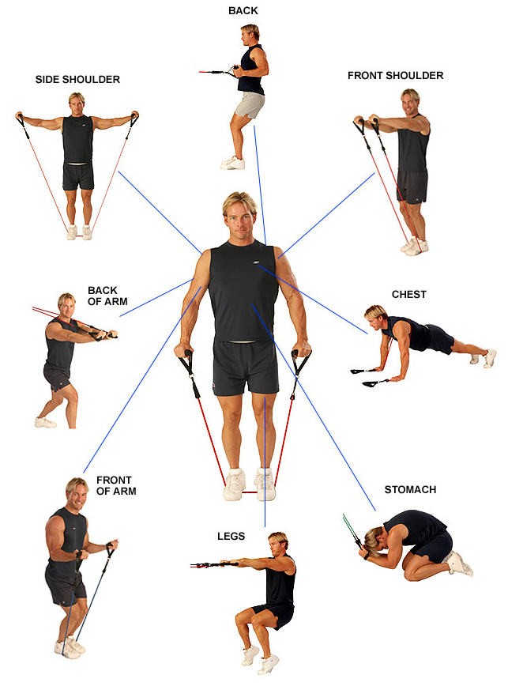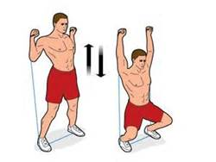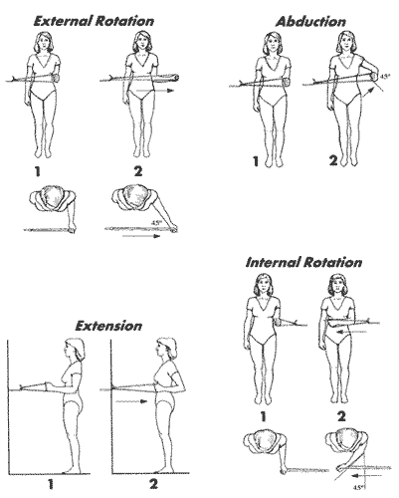

**Going through the “Pre-hab” workout, what do you think the focus of the exercises are and how does this “prehab” that are different than the “traditional approach”? What is the key factor in preventing injuries with this program? (Reflect your thoughts below on Pre-hab)**

­­­­­­­­­­­­­­­­­­­­­­­­­­­­­­­­­­_____________________________________________________________________________________

_____________________________________________________________________________________

_____________________________________________________________________________________

_____________________________________________________________________________________

_____________________________________________________________________________________

_____________________________________________________________________________________

**Although “Pre-hab” or preventative exercise is great at mitigating the onset of injuries, they still do happen. If an injury does occur, an athlete will often go through three phases of care:**

**The first phase of care is known as the ACUTE PHASE:**

This phase of care occurs immediately after the injury and there is often pain, swelling, loss of motion, and tenderness to the affected area.

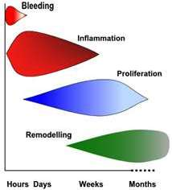

**What is the “RICE” treatment?**

_____________________________________________________________________________________

_____________________________________________________________________________________

**Why is it so critical to perform RICE during the first 72 hours?**

_____________________________________________________________________________________

_____________________________________________________________________________________

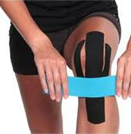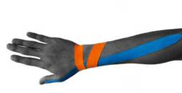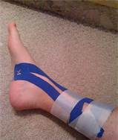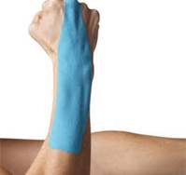

**Mini Lab**

**You will be assigned a specific injury and will be instructed on how it is managed during the first 72 hours. You will learns and practice taping methods, wrapping and get to experience a physical therapy unit that is used on athletes who have had sprains and strains!**

**Your personal reflections below on what you did in lab and on what body part you practiced on.**

_____________________________________________________________________________________

_____________________________________________________________________________________

_____________________________________________________________________________________

_____________________________________________________________________________________

**The next Phase of care is the SUB ACUTE phase of care:**

The sub-acute phase usually lasts for about three to fourteen days and in this phase the athlete will began to feel better. The athlete can stop doing the ice, but may still need wrap, tape, or provide a support to the injury. Oftentimes, they feel as if they are ready to get back in the game. However, the body has not completely healed and you run the risk of re-injuring the already affected area. However, it is important during this phase that you start doing some light, pain-free exercises to improve mobility to the joint and muscle. One of the most important exercises in this phase is Range of Motion and light stretching.

**Mini Lab**

**During this phase of rehabilitation you will be performing range of motion of the neck, shoulder, elbow, and wrist. I will go over normal ROM for each joint and you will have a chance to practice with an instrument called a “goniometer”.**

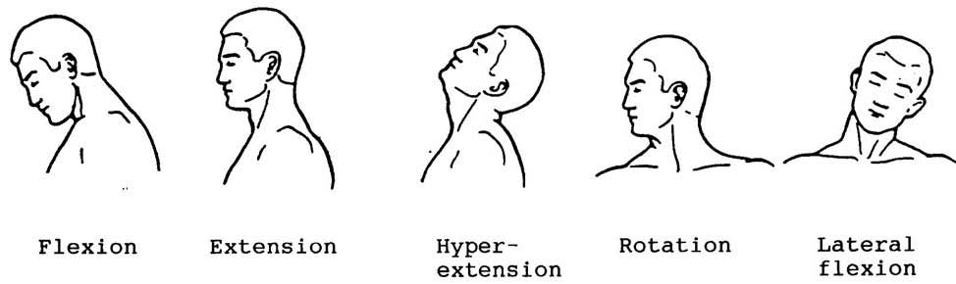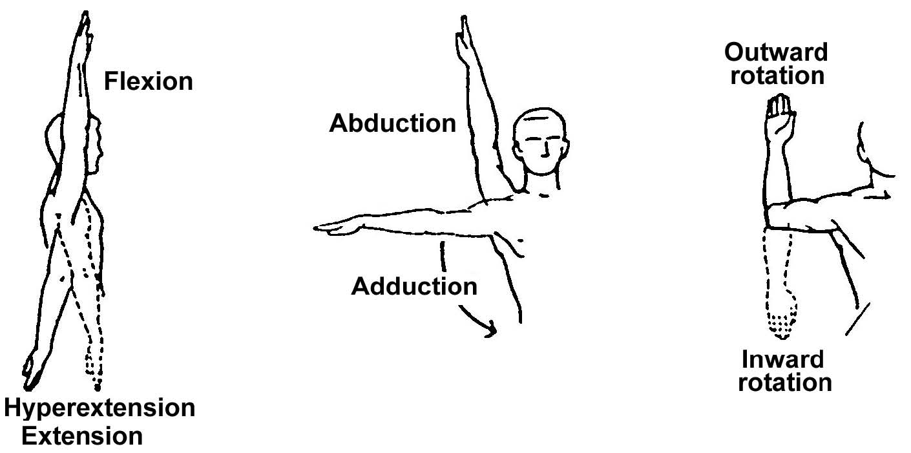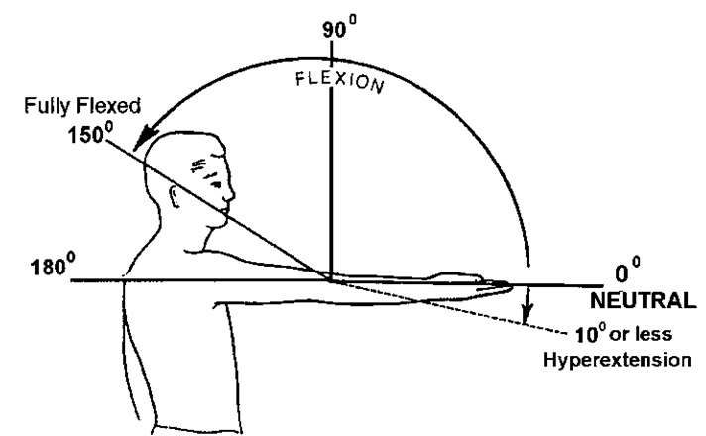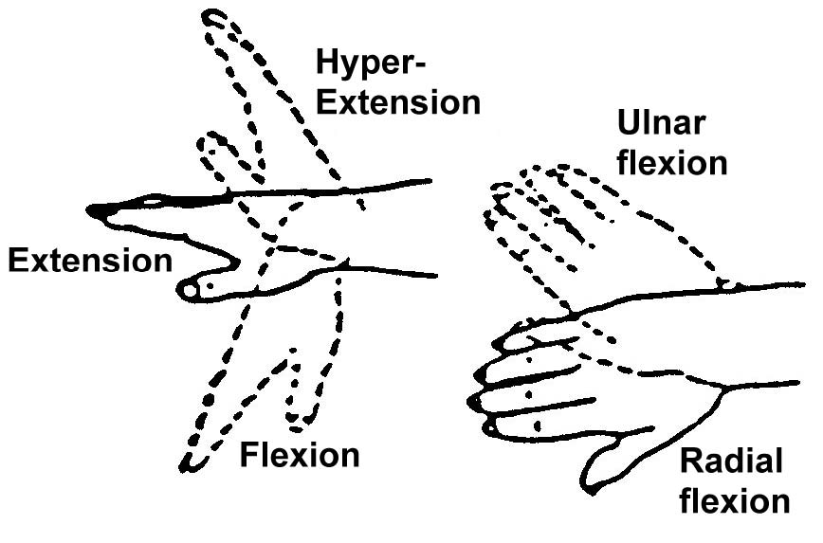

**What was the ROM of your neck in rotation? (Turning head from side to side)**

_____________________________________________________________________________________

_____________________________________________________________________________________

**What type of joint is the shoulder? How many different planes of motion are there in the shoulder?**

_____________________________________________________________________________________

_____________________________________________________________________________________

**What type of joint is the elbow? How many planes of motion are in the elbow joint?**

_____________________________________________________________________________________

_____________________________________________________________________________________

**What type of joint is the wrist joint? How many planes of motion are there in the wrist joint?**

_____________________________________________________________________________________

_____________________________________________________________________________________

**The other significant part of the Sub- acute phase is light stretching and flexibility. The key to this phase is that the muscles that are shortened need to be __________________________ ! It is a very simple concept. If the athlete does not have a normal ROM than the prescription is to lengthen the muscle. If the ROM is normal than it is not necessary and the athlete can start some light strengthening exercises.**

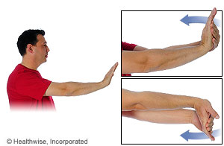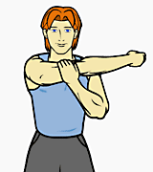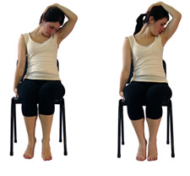

The final phase of Rehabilitation is the Restorative or Remodeling phase(it has also been coined the chronic phase). This is marked by progressive strengthening exercises along with continued flexibility, and agility exercises for balance and core strength. This phase is also marked by sport specificity training. Whatever your sport is, it is imperative that the athlete begin to train for that sport again. This “chronic” phase is meant to be a long term phase. In other words, as long as they are going to be continued to be “in the game” then it is necessary to stay on top of these exercises.

**Some key strengthening exercises:**

**Four key strengthening exercises for healthy individuals: Proper form is everything!**

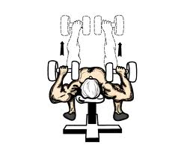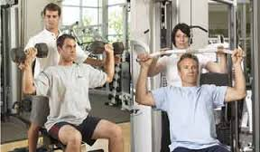

**Dumbell Chest Press Shoulder Press with Lat Pulldown**

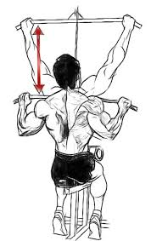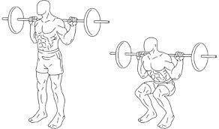

**Squats Lat pulldown**

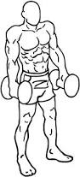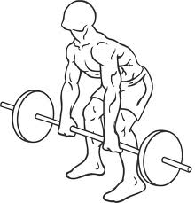

**Deadlifts** **Shoulder shrugs**

**Mini Lab**

**You will try the grip strength equipment called the hand “dynamometer” and measure your strength in the left and right hand. Grip strength may be indicative of overall strength. Write the actual numbers below.**

**Right hand strength is:___________________foot/lbs**

**Left hand strength is_____________________foot/lbs**

**Remember, as an athlete, prevention is your best medicine. This incorporates solid exercise and “perfect practice” of your sport. “Perfect practice” ties into a field called “Biomechanics”.**

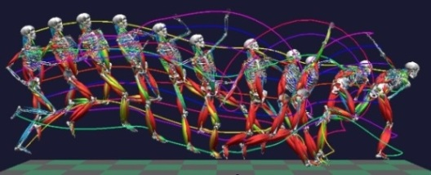

**What is Biomechanics?**

_____________________________________________________________________________________

_____________________________________________________________________________________

_____________________________________________________________________________________

_____________________________________________________________________________________

_____________________________________________________________________________________

_____________________________________________________________________________________

**Mini Lab**

**The students will engage in various forms of throwing, kicking, swinging, and jumping activities to analyze proper form during sport. With the use of improper form comes the risk of increased injury. We will analyze our form and break it down biomechanically.**

**Reflective Questions:**

**Why is it so important to start care immediately following an injury?**

_____________________________________________________________________________________

_____________________________________________________________________________________

_____________________________________________________________________________________

_____________________________________________________________________________________

_____________________________________________________________________________________

_____________________________________________________________________________________

**What specific role does exercise play when treating an injury?**

_____________________________________________________________________________________

_____________________________________________________________________________________

_____________________________________________________________________________________

_____________________________________________________________________________________

_____________________________________________________________________________________

_____________________________________________________________________________________

**What is the difference between strength training, flexibility, and agility?**

_____________________________________________________________________________________

_____________________________________________________________________________________

_____________________________________________________________________________________

_____________________________________________________________________________________

**Topic 3: The Keys to Peak Performance: “Fitness”, “Diet”, and “Nutrition Science”, & ” Mindset”**

Fitness is an interesting word because someone can appear to be “fit” in one aspect but not be fit in another aspect. In other words, one may have great endurance, but little strength, or very strong and lean, but little endurance. Body fat also plays a role in one’s level of fitness. If we look at the “most” fit athletes, they usually have a lower level of body fat. Not to say that an individual cannot be fit carrying extra body fat- it just makes it more challenging carrying that extra weight. In order to be very “fit” one must be engaged in a variety of activities and also have a diet that is balanced- incorporating some a large variety of foods that include fruits, vegetables, nuts, seeds, dairy, lean meats, and fish.

There are several categories of fitness that we can look at. The most ideal athletes are somewhat proficient in each category. The categories include the following areas: Cardiovascular endurance; muscular strength, speed, power, muscular endurance, flexibility, agility, body mass index, and body fat. Remember, you can still be a great athlete who has great skills for their sport, a great mindset, and understanding of the game and score pretty low on some of the fitness evaluations. It is important as a sports medicine specialist to understand all components of “fitness,” but also understand the components of drive, determination, and overall mental toughness.

**Lab**

You will engage in a variety of fitness tests and evaluations. These tests will include fitness evaluations that are done with many different populations. While it is encouraged that you participate, it is not mandatory at all. We can discuss the pros and cons of these tests as we view or get actively involved with them.

Video: [www.topendsports.com](http://www.topendsports.com)

**6 Minute Run Test**

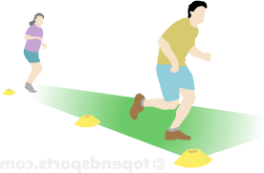

Running Fitness Test: The six minute run test has been developed as a shorter alternative to the 12 minute Cooper run test. There is also the six-minute walk test.

purpose: to test aerobic endurance fitness (the ability of the body to use oxygen as an energy source- or cardiovascular endurance.

equipment required: flat oval or running track, marking cones, recording sheets, stop watch.

procedure: Place markers at set intervals around the track to aid in measuring the completed distance. Participants run for 6 minutes, and the total distance covered is recorded. Walking is allowed, though the participants must be encouraged to push themselves as hard as they can.

results: No norm values are available for this test. To give you an idea of expected scores, The Newcastle Knights rugby team perform this test running around a 300m course. In a test conducted in 2008, one of their top players reached 1680m, 80m ahead of his nearest rival and well over a lap ahead of plenty of teammates (source: article online in the Daily Telegraph, July 2008).

target population: For those who are unfit or unable to run, there are similar walking tests that can be performed. (An alternative 6 minute walk test can be performed).

**Push Up Test**

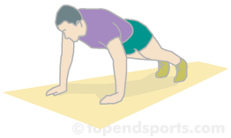

The push-up fitness test (also called the press up test) measures upper body strength and endurance.

There are many variations of the push up test, such as different placement of the hands, how far to dip, the duration of the test and the method of counting the number of completed push-ups.

possible equipment required: depending on which protocol you use, you will need a floor map

procedure: A standard push up begins with the hands and toes touching the floor, the body and legs in a straight line, feet slightly apart, the arms at shoulder width apart, extended and at a right angles to the body. Keeping the back and knees straight, the subject lowers the body to a predetermined point, to touch some other object, or until there is a 90-degree angle at the elbows, then returns back to the starting position with the arms extended. This action is repeated, and test continues until exhaustion, or until they can do no more in rhythm or have reached the target number of push-ups. See push up videos for some examples of push up fitness tests.

scoring: Record the number of correctly completed push-ups.

Variations: Here are just some of the variations as described on this site: Technique: Some variations of the push up test are designed to make it easier for certain populations, which may be required when testing people with weak upper body strength such as children, females and the elderly. The traditional female push-up technique is with the knees resting on the ground, which is an option on the Home Push Up Test. The test can also be made easier by raising the upper body such as in the chair push up test. How far to go down? In the President's Challenge version, an assistant places their hand at the point of 90 degree flexion to indicate the depth of the push up. The Army and Navy also require the upper arms are at least parallel to the ground in the lower position.

Alternative fitness tests to measure upper body strength are the pull up or chin up and flexed arm hang.

**1-RM Tests (Repetition maximum tests)**

* **purpose:** to measure maximum strength of various muscle and muscle groups.

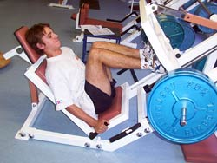

* **procedure:** One repetition maximum tests (1-RM) is a popular method of measuring [isotonic](http://www.topendsports.com/fitness/terms/isotonic.htm) muscle strength. It is a measure of the maximal weight a subject can lift with one repetition. It is important to reach the maximum weight without prior fatiguing the muscles. After a warm up, choose a weight that is achievable. Then after a rest of at least several minutes, increase the weight and try again. The athletes chooses subsequent weights until they can only repeat one full and correct lift of that weight.

**Abdominal strength test- Straight leg test**

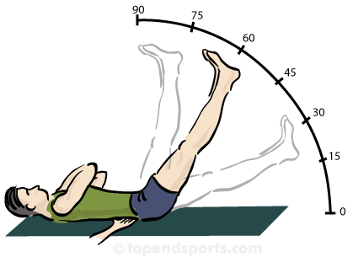

An alternative is to place hands under buttock or small of back.

**Curl Up / Sit-Up / Crunch Test**

This is a general description of a sit-up test to measure abdominal muscle endurance (also called curl up or crunch test).

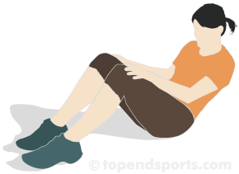

The procedures and technique for this test can vary depending on which specific test you are performing. See the procedures section for links to instructions for the specific abdominal endurance tests.

**Side Ramp**

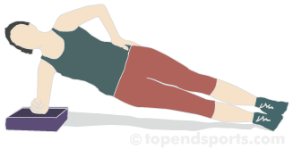

* **Purpose:** The side ramp test measures the control and endurance of the lateral core stabilizing muscles.
* **Equipment required:** flat, clean surface, [stopwatch](http://www.topendsports.com/resources/stores.htm?node=28&cat=Stopwatches), recording sheets, pen.

Scoring: The score is the total time completed for each side. Compare the performance on the two sides. The table below indicates guideline rating scores for both males and females.

Rating

Time (seconds)

Excellent > 90

Good 75 to 90

Average 60 to 75

Poor < 60

**Squat Test .**

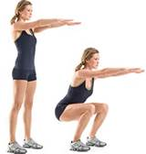

|  |  |  |  |  |  |
| --- | --- | --- | --- | --- | --- |
| **Age** | **20-29** | **30-39** | **40-49** | **50-59** | **60+** |
| **Excellent** | > 34 | > 32 | > 29 | > 26 | > 23 |
| **Good** | 33-34 | 30-32 | 27-29 | 24-26 | 21-23 |
| **Above average** | 30-32 | 27-29 | 24-26 | 21-23 | 18-20 |
| **Average** | 27-29 | 24-26 | 21-23 | 18-20 | 15-17 |
| **Below Average** | 24-26 | 21-23 | 18-20 | 15-17 | 12-14 |
| **Poor** | 21-23 | 18-20 | 15-17 | 12-14 | 9-11 |
| **Very Poor** | < 21 | < 18 | <15 | <12 | <9 |

**Squat Test (Women)**

|  |  |  |  |  |  |
| --- | --- | --- | --- | --- | --- |
| **Age** | **20-29** | **30-39** | **40-49** | **50-59** | **60+** |
| **Excellent** | >29 | >26 | >23 | >20 | >17 |
| **Good** | 27-29 | 24-26 | 21-23 | 18-20 | 15-17 |
| **Above average** | 24-26 | 21-23 | 18-20 | 15-17 | 12-14 |
| **Average** | 21-23 | 18-20 | 15-17 | 12-14 | 9-11 |
| **Below Average** | 18-20 | 15-17 | 12-14 | 9-11 | 6-8 |
| **Poor** | 15-17 | 12-14 | 9-11 | 6-8 | 3-5 |
| **Very Poor** | <15 | <12 | <9 | <6 | <3 |

**Wall Sit Test**

This is a simple test of lower body muscular strength and endurance.

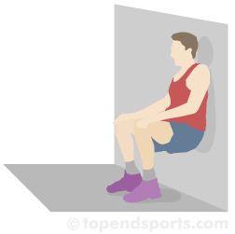

* **Purpose:** to measure the strength endurance of the lower body, particularly the quadriceps muscle group.
* **Equipment required:** smooth wall and a [stopwatch](http://www.topendsports.com/resources/stores.htm?node=28&cat=Stopwatches)
* **Procedure:** Stand comfortably with feet approximately shoulder width apart, with your back against a smooth vertical wall. Slowly slide your back down the wall to assume a position with both your knees and hips at a 90° angle. The timing starts when one foot is lifted off the ground and is stopped when the subject cannot maintain the position and the foot is returned to the ground. After a period of rest, the other leg is tested.
* **Scoring:** the total time in seconds that the position was held for each leg is recorded. The table below gives a general guideline to expected scores for a single leg for adults, based on my personal experiences. Comparing the scores for each leg may indicate muscle weakness on one side.

|  |  |  |
| --- | --- | --- |
| **rating** | **males (seconds)** | **females (seconds)** |
| excellent | >100 | > 60 |
| good | 75-100 | 45-60 |
| average | 50-75 | 35-45 |
| below average | 25-50 | 20-35 |
| very poor | < 25 | < 20 |

**30 Second Endurance Jump**

The 30 Second Endurance Jump was once part of the [SPARQ rating system](http://www.topendsports.com/testing/sparq-rating-system.htm) for [basketball](http://www.topendsports.com/sport/basketball/basketball-sparq.htm) and [soccer](http://www.topendsports.com/sport/soccer/soccer-sparq.htm), and the protocol they used is listed here.

* **Purpose:** The 30 Second Endurance Jump is a test of agility and lower body strength endurance
* **Equipment required:** a [stopwatch](http://www.topendsports.com/resources/stores.htm?node=28&cat=Stopwatches) and SPARQ Soft Endurance Hurdle (12" high)
* **Procedure:** Stand comfortably with both feet flat on the ground, perpendicular to the hurdle.The timing starts from the first movement. The athlete jumps off both feet and lands on both feet on the other side of the hurdle, then back again. The test continues for 30 seconds, with the total number of jumps counted.
* **Scoring:** The total number of completed jumps in the time period is recorded.
* **Results:** US Decathlete Bryan Clay achieved 67 jumps in 30 seconds in this test during a SPARQ testing exercise (published in SPARQ Magazine, Summer 2008).
* **Target population:** basketball and soccer

**Handgrip Strength Test**

|  |
| --- |
| [Camry Hand Dynamometer](http://www.topendsports.com/testing/products/grip-dynamometer/index.htm) |

The purpose of this test is to measure the maximum isometric strength of the hand and forearm muscles. Handgrip strength is important for any sport in which the hands are used for catching, throwing or lifting. Also, as a general rule people with strong hands tend to be strong elsewhere, so this test is often used as a general test of strength.

* **Equipment required:** handgrip [dynamometer](http://www.topendsports.com/resources/stores.htm?node=37&cat=Grip%20Strength%20Dynamometers)
* **Procedure:** The subject holds the dynamometer in the hand to be tested, with the arm at right angles and the elbow by the side of the body. The handle of the dynamometer is adjusted if required - the base should rest on first metacarpal (heel of palm), while the handle should rest on middle of four fingers. When ready the subject squeezes the dynamometer with maximum isometric effort, which is maintained for about 5 seconds. No other body movement is allowed. The subject should be strongly encouraged to give a maximum effort. See videos of the [Handgrip Strength Test](http://www.topendsports.com/videos/category/testing/strength/grip/)
* **Variations:** The position of the arm and hand can vary in different grip strength protocols. Various positions include the elbow being held at right angles as per the above procedure, the arm hanging by the side, and the extended arm being swung from above the head to by the side during the squeezing motion. The [Eurofit Test Manual](http://www.topendsports.com/testing/eurofit.htm) recommends squeezing for 3 seconds. The procedure for the [Groningen Elderly Tests](http://www.topendsports.com/testing/groningen-elderly-tests.htm) has the subject hang their hand by their side, one practice trial, best of three attempts with 30 seconds rest between.
* **Scoring:** The best result from several trials for each hand is recorded, with at least 15 seconds recovery between each effort. The values listed below (in kg and lbs) give a guide to expected scores for adults. These values are the average of the best scores of each hand. See more [Hand Grip Strength Norms](http://www.topendsports.com/testing/products/grip-dynamometer/norms.htm). Other protocols will just use the score from the dominant hand, or compare the left and right hand results. See also examples of some actual [athlete results](http://www.topendsports.com/testing/results/grip-strength.htm).

|  |  |  |  |  |
| --- | --- | --- | --- | --- |
|  | **MALES** | | **FEMALES** | |
| **rating\*** | **(lbs)** | **(kg)** | **(lbs)** | **(kg)** |
| excellent | > 141 | > 64 | > 84 | > 38 |
| very good | 123-141 | 56-64 | 75-84 | 34-38 |
| above average | 114-122 | 52-55 | 66-74 | 30-33 |
| average | 105-113 | 48-51 | 57-65 | 26-29 |
| below average | 96-104 | 44-47 | 49-56 | 23-25 |
| poor | 88-95 | 40-43 | 44-48 | 20-22 |
| very poor | < 88 | < 40 | < 44 | < 20 |

*\* norms for adults. source and population group unknown*

**Vertical Jump Test (Sargent Jump, Vertical Leap)**

This procedure describes the method used for directly measuring the vertical jump height jumped. There are also timing systems that measure the [time of the jump](http://www.topendsports.com/testing/tests/vertical-jump.htm) and from that calculate the vertical jump height.

* **Equipment required:** [measuring tape](http://www.topendsports.com/resources/stores.htm?node=30&cat=Tape%20Measures) or [marked wall](http://www.topendsports.com/testing/products/vertical-jump.htm), chalk for marking wall (or [Vertec](http://www.topendsports.com/testing/equipment-vertec.htm) or [jump mat](http://www.topendsports.com/testing/equipment-jumpmat.htm)).

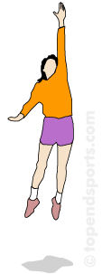

* **Procedure (see also variations below):** the athlete stands side on to a wall and reaches up with the hand closest to the wall. Keeping the feet flat on the ground, the point of the fingertips is marked or recorded. This is called the standing reach height. The athlete then stands away from the wall, and leaps vertically as high as possible using both arms and legs to assist in projecting the body upwards. The jumping technique can or cannot use a countermovement (see [vertical jump technique](http://www.topendsports.com/testing/vertical-jump-technique.htm)). Attempt to touch the wall at the highest point of the jump. The difference in distance between the standing reach height and the jump height is the score. The best of three attempts is recorded.
* **Variations:** The vertical jump test can also be performed using a specialized apparatus called the [Vertec](http://www.topendsports.com/testing/equipment-vertec.htm). The procedure when using the Vertec is very similar to as described above. Jump height can also be measured using a [jump mat](http://www.topendsports.com/testing/equipment-jumpmat.htm) which measures the displacement of the hips. To be accurate, you must ensure the feet land back on the mat with legs nearly fully extended. Vertical jump height can also be measured [using a timing mat](http://www.topendsports.com/testing/tests/vertical-jump.htm). The vertical jump test is usually performed with a counter movement, where there is bending of the knees immediately prior to the jump. The test can also be performed as a squat jump, starting from the position of knees being bent. Other test variations are to perform the test with no arm movement (one hand on hip, the other raised above the head) to isolate the leg muscles and reduce the effect of variations in coordination of the arm movements. The test can also be performed off one leg, with [a step into the jump](http://www.topendsports.com/testing/tests/vertical-jump-one-step.htm), or with a run-up off [two feet](http://www.topendsports.com/testing/tests/vertical-jump-runup.htm) or [one foot](http://www.topendsports.com/testing/tests/vertical-jump-running.htm), depending on the relevance to the sport involved. For more details see [vertical jump technique](http://www.topendsports.com/testing/vertical-jump-technique.htm).

# Sit and Reach Flexibility Test

* The sit and reach test is a common measure of flexibility, and specifically measures the flexibility of the lower back and hamstring muscles. This test is important as because tightness in this area is implicated in lumbar lordosis, forward pelvic tilt and lower back pain. This test was first described by Wells and Dillon (1952) and is now widely used as a general test of flexibility.

## About Test Variations

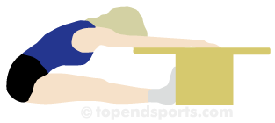

* There are a few variations of the test. Many of the variations of this test involve the differences in the value of the level of the feet.
* The most logical measure is to use the level of the feet as recording zero, so that any measure that does not reach the toes is negative and any reach past the toes is positive (such as for [PRT Sit and Reach](http://www.topendsports.com/testing/tests/sit-reach-prt.htm) for the Navy). However, using negative values is more difficult for statistical analyses, and for comparing results. The procedure for the [Presidents Challenge](http://www.topendsports.com/testing/tests/sit-and-reach-presidents.htm) version require that the box is made with 9 inches (23 cm) at the level of the feet, so reaching two inches past the toes is recorded as 11 inches. The [Eurofit](http://www.topendsports.com/testing/eurofit.htm) manual suggests having 15cm at the level of the feet, and also 10 inches has been used (NHL combine testing).

**40 Yard Dash**

Sprint or speed tests can be performed over varying distances, depending on the factors being tested and the relevance to the sport. The 40 Yard (36.6 meters) Dash is part of the [SPARQ rating system for football](http://www.topendsports.com/sport/gridiron/football-sparq.htm), and their protocol is listed here.

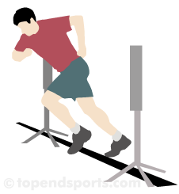

* **Purpose:** The aim of this test is to determine acceleration, and also a reliable indicator of speed, agility and quickness.
* **Equipment required:** [measuring tape](http://www.topendsports.com/resources/stores.htm?node=30&cat=Tape%20Measures) or marked track, [stopwatch](http://www.topendsports.com/resources/stores.htm?node=28&cat=Stopwatches) or [timing gates](http://www.topendsports.com/testing/timing-gates.htm), [cone markers](http://www.topendsports.com/resources/stores.htm?node=29&cat=Cones), flat and unobstructed grass, track, or turf surface of at least 60 yards.
* **Procedure:** The test involves running a single maximum sprint over 40 yards, with the time recorded. A thorough warm up should be given, including some practice starts and accelerations. Start from a comfortable stationary 3-point stance position, a position that is most familiar to you and that you think will yield the best time. The front foot must be on or behind the starting line. This starting position should be held for 3 seconds prior to starting, you may lean across the starting line, and no rocking movements are allowed. The tester should provide hints to maximizing speed and encouragement to continue running hard past the finish line. See video examples of the [Sprint Tests](http://www.topendsports.com/videos/testing/speed/).

|  |  |
| --- | --- |
| **40 yard Sprint Scores  (general guidelines)** | |
| College Footballers | 4.6 - 4.9 secs |
| High School Footballers | 4.9 - 5.6 secs |
| Recreational College athletes (male) | ~5.0 secs |
| Recreational College athletes (female) | ~5.8 secs |

* **Results:** Two trials are allowed, and the best time is recorded to the nearest 2 decimal places. The timing starts from the first movement (if using a stopwatch) or when the timing system is triggered, and finishes when the chest crosses the finish line and/or the finishing timing gate is triggered.
* **Target population:** football and other sports in which speed over that distance is important
* **Reliability:** Reliability is greatly improved if timing gates are used. Also weather conditions and running surface can affect the results, and these conditions should be recorded with the results. If possible, set up the track with a crosswind to minimize the effect of wind.
* **Comments:** 40 yards is 36.58 meters.

**Skinfold Measurement .**

Taking skinfold measurements is a common method for determining body fat composition. Accurate measurement technique is important. Here is the standard technique that is used. You should read this information in conjunction with the description of each of the standard

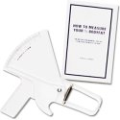

* **Equipment:** [skinfold calipers](http://www.topendsports.com/resources/stores.htm?node=19&cat=Skinfold%20Calipers), [tape measure](http://www.topendsports.com/resources/stores.htm?node=30&cat=Tape%20Measures)
* **Procedure:** Estimation of body fat by skinfold thickness measurement. Measurement can use from 3 to 9 different standard anatomical sites around the body. The right side is usually only measured (for consistency). The tester pinches the skin at the appropriate site to raise a double layer of skin and the underlying adipose tissue, but not the muscle. The calipers are then applied 1 cm below and at right angles to the pinch, and a reading in millimeters (mm) taken two seconds later. The mean of two measurements should be taken. If the two measurements differ greatly, a third should then be done, then the median value taken.
* **The sites:** there are many common sites at which the skinfold pinch can be taken. See the [descriptions and photographs of each skinfold site](http://www.topendsports.com/testing/skinfold-sites.htm).
* **Results:** Because of the increased errors involved, it is usually not appropriate to convert skinfold measures to percentage body fat (%BF). It is best to use the sum of several sites to monitor and compare body fat measures. In order to satisfy those who want to calculate a percentage body fat measure, there is a sample of equations for calculating this [here](http://www.topendsports.com/testing/bodyfat-percent.htm). **Below is a table of general guidelines (based on personal experience) for using total sum (in millimeters) of the seven main skinfold sites (**[**tricep**](http://www.topendsports.com/testing/skinfold-tricep.htm)**,** [**bicep**](http://www.topendsports.com/testing/skinfold-bicep.htm)**,** [**subscap**](http://www.topendsports.com/testing/skinfold-subscapular.htm)**,** [**supraspinale**](http://www.topendsports.com/testing/skinfold-supraspinale.htm)**,** [**abdominal**](http://www.topendsports.com/testing/skinfold-abdominal.htm)**,** [**thigh**](http://www.topendsports.com/testing/skinfold-front-thigh.htm)**,** [**calf**](http://www.topendsports.com/testing/skinfold-medial-calf.htm)**). There are also examples of some actual** [**athlete results**](http://www.topendsports.com/testing/results/skinfolds.htm)**.**

|  |  |  |  |  |  |  |
| --- | --- | --- | --- | --- | --- | --- |
|  | | **excellent** | **good** | **average** | **below average** | **poor** |
| **Normal** | **Male** | 60-80 | 81-90 | 91-110 | 111-150 | 150+ |
| **Female** | 70-90 | 91-100 | 101-120 | 121-150 | 150+ |
| **Athletic** | **Male** | 40-60 | 61-80 | 81-100 | 101-130 | 130+ |
| **Female** | 50-70 | 71-85 | 86-110 | 111-130 | 130+ |

**Illinois Agility Test**

Agility is an important component of many team sports, though it is not always tested, and is often difficult to interpret results. The Illinois Agility Test (Getchell, 1979) is a commonly used test of agility in sports, and as such there are many norms available.

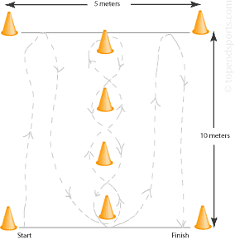

* **Purpose:** to test running agility
* **Equipment required:** flat non-slip surface, [marking cones](http://www.topendsports.com/resources/stores.htm?node=29&cat=Cones), [stopwatch](http://www.topendsports.com/resources/stores.htm?node=28&cat=Stopwatches), [measuring tape](http://www.topendsports.com/resources/stores.htm?node=30&cat=Tape%20Measures), [timing gates](http://www.topendsports.com/testing/timing-gates.htm) (optional)
* **Procedure:** The length of the course is 10 meters and the width (distance between the start and finish points) is 5 meters. Four cones are used to mark the start, finish and the two turning points. Another four cones are placed down the center an equal distance apart. Each cone in the center is spaced 3.3 meters apart. Subjects should lie on their front (head to the start line) and hands by their shoulders. On the 'Go' command the stopwatch is started, and the athlete gets up as quickly as possible and runs around the course in the direction indicated, without knocking the cones over, to the finish line, at which the timing is stopped  
  **Results**: The table below gives some rating scores for the test

|  |  |  |
| --- | --- | --- |
| **Agility Run Ratings (seconds)** | | |
| **Rating** | **Males** | **Females** |
| Excellent | < 15.2 | < 17.0 |
| Good | 16.1-15.2 | 17.9-17.0 |
| Average | 18.1-16.2 | 21.7-18.0 |
| Fair | 18.3-18.2 | 23.0-21.8 |
| Poor | > 18.3 | > 23.0 |

**DNA Fitness Test**

DNA fitness testing refers to the analysis of a person's genes and relating these to athletic potential. One such company, DNAlysis technology, uses a South African developed process that detects the type of exercise best suited to athletes through gene analysis. It was launched on the global market by UK-based Lasarow Healthcare Technologies in 2013. The results help athletes realize their natural potential by detecting what type of exercise is best suited to their individual genetic profile.

* **Aim:** to analyze a person's DNA for marker genes which provide information about an individual's genetic propensity to certain sports or athletic events.
* **Equipment required:** the DNA analysis requires sophisticated medical equipment.
* **Procedure:** One company sends out collection kits for you to take the DNA sample and to send it back for analysis. For collection, all you need is a scraping from the inside of your cheek onto a sterile swab.
* **Results:** The gene sample is analyzed and the genotype report provides information about an individual's genetic propensity to power and endurance performance, his or her risk of getting soft tissue or tendon injuries and the optimal recovery time required between exercise sessions.
* **Target population:** this technology is best suited to juniors or recreational athletes who looking for guidance about which sport is best suited to them.
* **Disadvantages:** this test requires expensive equipment and is labor intensive.
* **Comments**: success in sports does not come down to just what genes you have. There are many other [factors of success in sports](http://www.topendsports.com/fitness/factors-of-success.htm). Gene testing would probably be more useful as a test for inherited disorders or inherited predisposition to disease, such as Huntington’s disease, cystic fibrosis or sickle cell anaemia.

**Posture Testing**

Here is a description of a basic posture assessment method, using a grid placed behind the subject. Posture testing can be useful for identifying and correcting postural deviations, and for prescribing exercise to correct posture or which is appropriate for a particular posture type. Postural deviations may be a result of muscle imbalances and lightness and weakness of particular joints and muscles.

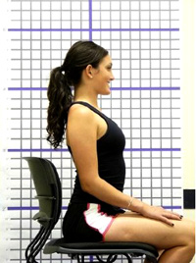

* **Aim:** to assess posture using a simple method
* **Equipment required:** [posture assessment grid](http://www.topendsports.com/testing/products/posture-grid.htm) (or similar wall with markings), camera (optional)
* **Procedure:** Shoes should be removed and minimal clothing worn. The subject stands in set distance in front of a posture grid, in a natural and relaxed stance. Using a camera to capture the image makes for easier analysis, though the assessment can also be done visually without a photo. The body alignment is checked against the horizontal or vertical lines. Check the alignment of the head, neck, spine, shoulders, hips, legs, ankles etc. Repeat the assessment to compare the subject's front, side and back posture.

* **Results:** this assessment can reveal a stiff or hypermobile spine, tight muscles, kyphosis, lordosis, scoliosis/spinal curvature, rounded shoulders, hyperextended joints, and an array of other alignment issues.
  + **Comments:** Keep the procedure standard in case you wish to repeat the procedure in future to assess changes in posture. The posture grid can also be used for range-of-motion (flexibility) measurements

**Lung Function Testing**

Lung function testing is sometimes performed as part of a health check-up. For athletes, it can be used to assess the degree of exercise induced asthma, and determine the efficacy of medical treatment.

* **Procedure:** The usual measures of lung function are of forced vital capacity (FVC) and forced expired volume in 1 second (FEV1). These can be measured with a full maximal expiration. Explain to the subject that they must fill their lungs completely, seal their lips around the mouthpiece, and empty their lungs as hard and fast as possible. The best of two trials is usually recorded.

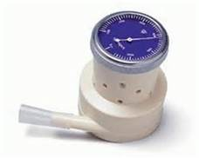

**Exercise Stress Testing**

An exercise stress test is commonly conducted by health professionals to determine cardiac function of people with heart disease risk factors.

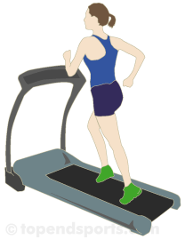

* **Procedure:** A progressive and maximum exercise test (starting from a walking pace and gradually increasing pace) is performed while the electrical impulses from the heart tissue are recorded by surface electrodes places on the chest wall.
* **Equipment required:** Exercise machine such as a [treadmill](http://www.topendsports.com/resources/stores.htm?node=23&cat=Treadmills) or [exercise bike](http://www.topendsports.com/resources/stores.htm?node=24&cat=Exercise%20Bikes), a 12-lead [ECG machine](http://www.topendsports.com/resources/stores.htm?node=26&cat=ECG) and leads, sticking tape, clips and other sundries as required.
* **Analysis**: Specialist training is required to interpret exercise ECG traces. Many of the stress testing machines can perform basic analysis, though these should not be relied on fully and a well-trained human eye should look at the results before any conclusions are made.
* **Comments**: See your doctor is you think you need a stress test performed. A stress test can pick up early changes in the heart function indicating potential heart disease. The test is also known as a cardiac stress test.
* **Qualifications:** Stress tests are either performed by a medical practitioner, or a qualified health specialist with a doctor nearby.

**Vision Testing for Athletes**

Vision is very important in sports, such as being able to focus on the ball and opposition players, watching the play down field, and seeing the ball and players in your periphery. Testing the eyes (vision testing) is not widely conducted for athletes, though there are many people (including optometrists and ophthalmologists) who believe that it is very worthwhile to test athlete vision, and with specific treatment and training athletes improve their performance.

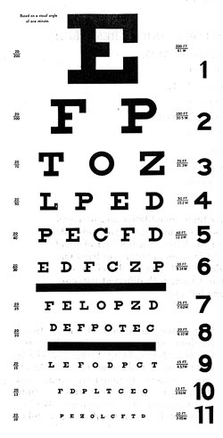

* **Equipment required:** eye chart (e.g. Snellen chart), computer software and other equipment developed to test athlete vision, specialist optometry equipment.
* **Visual Acuity** — Vision is often tested using a Snellen chart or similar, the traditional eye examination. Being able to read the line designated 20/20 (usually the 8th row), is the smallest line that a person with normal acuity can read at a distance of twenty feet. Outside the US, six meters is used and normal vision is designated 6/6. Good visual acuity means the athlete is able to sharply focus on the ball and opposition players. Vision can be corrected with spectacles or contact lenses, which are available in forms that are appropriate for playing sports.
* **Depth Perception** — ability to locate items in space. Good binocular vision, when both eyes are working equally well, is linked to better depth perception. .

**Body Mass Index (BMI)**

BMI stands for Body Mass Index. It is a measure of body composition. BMI is calculated by taking a person's weight and dividing by their height squared. For instance, if your height is 1.82 meters, the divisor of the calculation will be (1.82 * 1.82) = 3.3124. If your weight is 70.5 kilograms, then your BMI is 21.3 (70.5 / 3.3124) (see calculator links below).

The higher the figure the more overweight you are. Like any of these types of measures it is only an indication and other issues such as body type and shape have a bearing as well. Remember, BMI is just a guide - it does not accurately apply to elderly populations, pregnant women or very muscular athletes such as weight lifters. **Calculate your own BMI !**

* If you are from the US and want to enter your height in feet and inches, and weight in pounds, use [this calculator](http://www.topendsports.com/testing/BMIcalc1.htm).
* For the rest of the world, there is a [metric version](http://www.topendsports.com/testing/BMIcalc2.htm) for entering height in meters and weight in kilograms.

**Test Details**

**Equipment required:** [scales](http://www.topendsports.com/resources/stores.htm?node=20&cat=Weight%20Scales) and [stadiometer](http://www.topendsports.com/resources/stores.htm?node=21&cat=Stadiometers) as for weight and height.

* **Procedure:** BMI is calculated from [body mass](http://www.topendsports.com/testing/tests/mass.htm) (M) and [height](http://www.topendsports.com/testing/tests/height.htm) (H). BMI = M / (H x H), where M = body mass in kilograms and H = height in meters. The higher the score usually indicating higher levels of body fat.
* **Scoring:** Use the table below to determine your BMI rating. The table shows the World Health Organization BMI classification system. The rating scale is the same for males and females. You can also use the reverse lookup [BMI table](http://www.topendsports.com/testing/BMI-table.htm) for determining your ideal weight based on height.

|  |  |  |  |  |
| --- | --- | --- | --- | --- |
| **classification** | **BMI (kg/m2)** | **sub-classification** | | **BMI (kg/m2)** |
| underweight | < 18.50 | Severe thinness | | < 16.00 |
| Moderate thinness | | 16.00 - 16.99 |
| Mild thinness | | 17.00 - 18.49 |
| normal range | 18.5 - 24.99 | normal | | 18.5 - 24.99 |
| overweight | ≥ 25.00 | pre-obese | | 25.00 - 29.99 |
| Obese (≥ 30.00) | obese class I | 30.00 - 34.99 |
| obese class II | 35.00 - 39.99 |
| obese class II | ≥ 40.00 |

*source: World Health Organization*

* **Target population:** BMI is often used as a general population measure to determine the level of health risk associated with obesity.
* **Advantages:** only simple calculations are required from standard height and weight measurements.
* **Disadvantages:** in certain populations BMI can be inaccurate as a measure of body fatness, for example large and muscular though lean athletes may score high BMI levels which incorrectly rates them as obese.
* **Other comments:** Other simple measures of body composition, such as [skinfolds](http://www.topendsports.com/testing/tests/skinfolds.htm) measures, would be preferable if available.

**Choose three tests you learned about today and explain how they correlate to an athlete’s fitness levels?**

______________________________________________________________________________

______________________________________________________________________________

______________________________________________________________________________

______________________________________________________________________________

______________________________________________________________________________

______________________________________________________________________________

______________________________________________________________________________

______________________________________________________________________________

______________________________________________________________________________

______________________________________________________________________________

______________________________________________________________________________

**Topic 4: Nutrition Science, Sports Supplements, & PED’s**

The role of nutrition science in sports performance has been changing dramatically over the past two decades. There is research coming out every day on the latest supplements and the role they “may” play in overall fitness and performance. But even with all the advancements in Nutrition science- it still comes down to the basics of eating right? The question to many is what is eating right? At this time we will do a little review of the basic food groups and their significance to better health and better performance!

**The Food Pyramid**

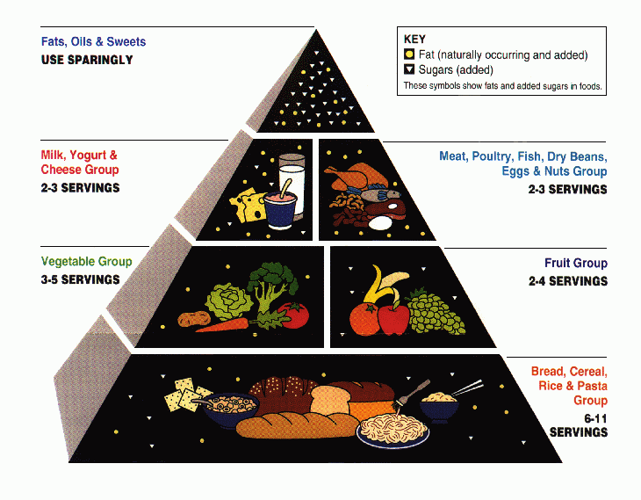

**A modified version of the Food pyramid**.

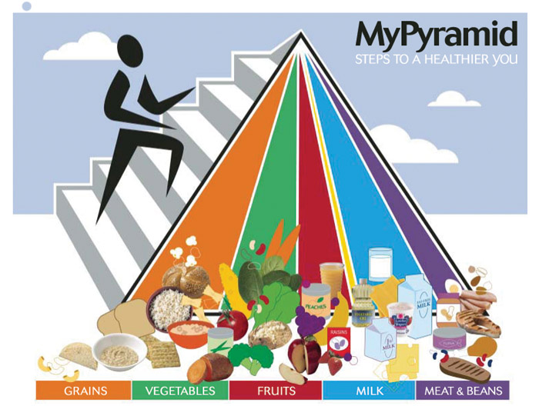

**My Plate**

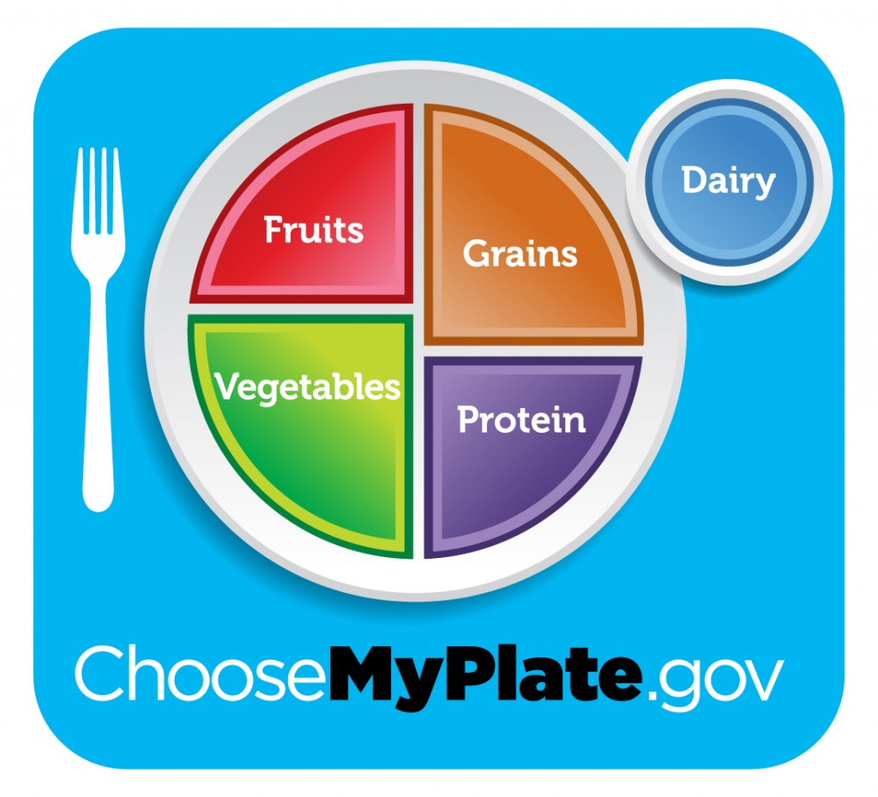

**A great Visual to help you see how your plate needs to be filled up!**

**MyPlate** illustrates the five food groups that are the building blocks for a healthy diet using a familiar image—**a place setting for a meal**. Before you eat, think about what goes on your plate or in your cup or bowl. To learn more about building a healthy plate, select a food group below.

**Get Your Motor Running**

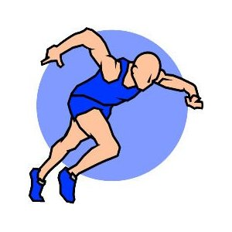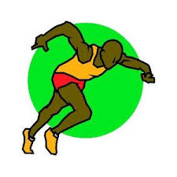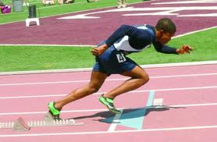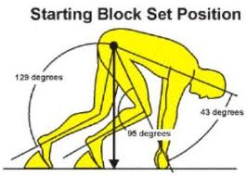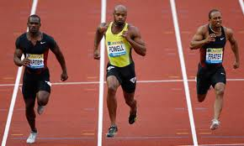

**What You Need To Know:**

 Energy and Fuel comes from food and is measured in ________________

 Calories come from Carbohydrates, _______________,and Fat

 The Best fuel for our muscles is__________________________

 High carbohydrate foods are grains, fruits, vegetables, dairy, and beans

You can store some extra carbohydrate as “____________” in your muscles.

**Training Diet** = Eating a high-carb diet of 450-550 grams/day to replace the glycogen you burn during training. How many calories per gram of carbohydrate?

So what are some **high carbohydrate foods**?

______________________________________________________________________________

|  |  |  |  |  |  |  |  |  |  |  |  |  |  |  |  |  |  |
| --- | --- | --- | --- | --- | --- | --- | --- | --- | --- | --- | --- | --- | --- | --- | --- | --- | --- |
| **Grains** | | | | **Vegetables** | | | **Fruits** | | **Dairy** | | | | | **Meats** | | | |
| Food | Grams | | | food | grams | | food | grams | food | | | grams | | food | | | grams |
| Kaiser roll | 30 | | | Large baked potato | 30-50 | | ¼ cup of dried fruit | 30 | 1 cup of fruit yogurt | | | 42 | | 1 cup of most beans | | | 40-45 |
| ½ cup of rice | 28 | | | 1 ear of corn on the cob | 19 | | Banana | 27 | ½ cup of chocolate pudding | | | 27 | | ½ cup of refried beans | | | 23 |
| 1 oz cold cereal | 20-24 | | | ½ cup mashed potatoes | 18 | | 1 cup of orange juice | 25 | 1 cup of chocolate milk | | | 26 | | ½ cup of black-eyed peas | | | 18 |
| ½ cup of pasta | | 20 | ½ cup of green peas | | | 12 | | ½ cup of applesauce | | 25 | | | ½ cup of frozen yogurt | | | 13 | |
| ½ bagel | | 19 | 1 cup of collard greens | | | 11 | | Apple | | 21 | | | 1 cup of low-fat milk | | | 12 | |
| ½ English muffin | | 14 | 1 cup  of peppers | | | | | 9 | | | 1 cup of grapes | | | | 20 | | |
| 1 slice of bread | | 13 | ½ cup of  cooked carrots | | | | | 8 | | | Orange | | | | 15 | | |

USDA National Nutrient Database.

What can you eat tonight to raise your carbohydrate totals?

Eat to Compete

Pre-competition Meals – know what to eat and when to eat

 It takes ________hours for food to leave your stomach

 Foods high in carbohydrate leave your stomach the _____________

 Foods high in ________can stay in your stomach much longer (>4 hrs)

➔ Best choice for pre-game meals is something high in _______________

▪ Carbs are easy to digest and become quick energy

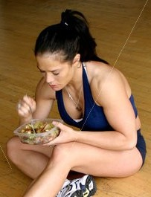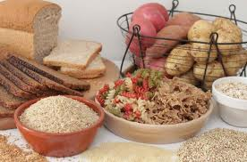

How much should you eat before competition/exercise?

▪ Figure out how much time (hours) you have before you exercise and

use the calorie amount that goes with it from the column on the right.

▪ Take that calorie amount and multiply it by your body weight in pounds.

|  |  |  |  |  |  |  |
| --- | --- | --- | --- | --- | --- | --- |
| **Time before exercise** | **Calories needed per pound of weight** | | **Your weight (pounds)** | | **# of calories you need to eat before practice** | |
| 1 hour | 2 | | X ________ pounds | | = __________ calories | |
| 2 hours | | | 4 | | | |
| 3 hours | | | 6 | | | |
| 4 hours | | | 8 | | | |
| You have 3 hours | So…6 times | | 140 pounds | | 840 calories | |
|  |  | |  | |  | |
| **Some Healthy Snacks and Small Meals to Match your Calorie Needs** | | | | | | | | |
| **200 calories** | | | **400 calories** | | **600 calories** | | **800 calories** | |
| 8 ounces of Yogurt | | | 1 ½ cups of cereal with 1 cup of skim milk and an apple | | 2 tablespoons of peanut butter and jelly on wheat bread and a piece of fruit | | 2 slices of turkey and cheese on a Kaiser roll with an orange and a cup of skim milk | |
| 1 English muffin with 1 tablespoon of jam | | | 1 bagel and 1 cup of grapes | | 2 slices of ham and cheese on a Kaiser with and an orange | | 2 cups of pasta with a cup of tomato sauce, 1 ½ cup of skim milk and a piece of fruit | |

**Snacks** – Snacks can be stored in your locker or gym bag for after school practices and games.

􀂃 Fresh fruit (apples, bananas, oranges, grapes)

􀂃 Baby carrots

􀂃 Celery, pepper, zucchini strips

􀂃 Granola and energy bars

􀂃 Crackers

􀂃 Fig bars

􀂃 Bags of dried fruit

􀂃 Peanuts

􀂃 Yogurt or pudding

􀂃 milk, water, 100% juice

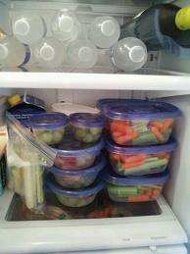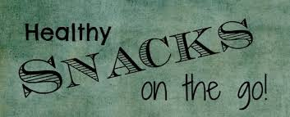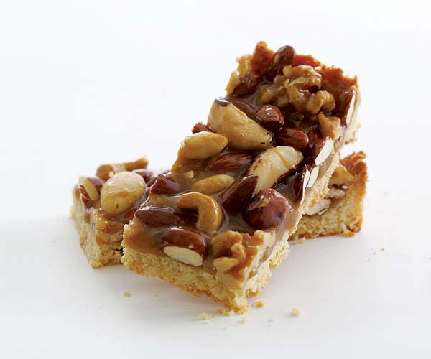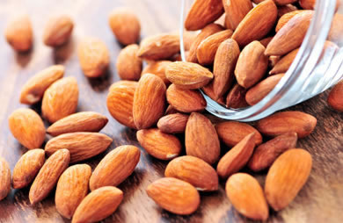

**Cafeteria** – Be sure to choose healthy, high carbohydrate lunches from the cafeteria on game day and before practices.

➔**On the Road** *– What’s the healthiest choice if you do have to eat at a fast food place on the way to a game or meet?*

 **Burger Joint** – single burger or grilled chicken sandwich and a small order of fries or baked potato

 **Convenience Store** – turkey and cheese hoagie and a piece of fruit

 **Pizza Place** – 2 slices of thin pizza with a veggie topping or a side salad with breadsticks

 **Mexican Place** – bean burrito and low-fat chips and salsa

 **What about drinks?** – typically should be low fat

➔**Other good ideas:**

▪ Order low fat milk instead of soda

▪ Choose broiled or grilled foods over fried

▪ Order food without mayonnaise or “special sauces” (choose BBQ sauce, ketchup or mustard)

▪ Go easy on the egg, tuna and pasta salads because they are typically made with a lot of mayonnaise

▪ Ask for double veggies on sandwiches

▪ Order a salad with dressing “on the side”

**Focus on Whole Grains for more energy, and nutritional value!**

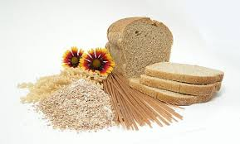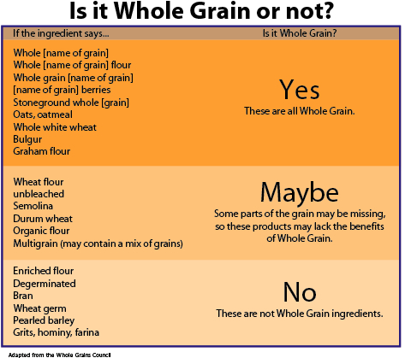

**Hydration & Recovery**

Best way to stay well hydrated is to drink Before, During and After you exercise.

|  |  |  |  |
| --- | --- | --- | --- |
|  |  |  |  |
| **Way Before**  Drink 2-3 cups of fluid 2 to 3 hours before playing | **Right Before**  Drink 1 cup of fluid 10 to 20 minutes before playing | **During**  Drink 1 cup of fluid every 15 minutes | **After** Drink at least 2 cups for every pound of lost weight |



**Remember! Drink regardless of whether you feel thirsty or not**

**The best drinks for recovering after a tough game or practice are milk and 100% juice because they contain important vitamins and minerals**.



**Mini Lab**

**Lets evaluate some common sports drinks and energy bars that are on the market. Evaluate as to whether these “sports drinks and bars” are worthy from a nutritional and energy stand point or are no different than the average candy bar or soda.**

Sports Drink #1:____________________________________

Summary of drink:

__________________________________________________________________

__________________________________________________________________

Overall Rating: (scale 1-10)______________________

Sports Drink #2:__________________________________

Summary of Drink:

__________________________________________________________________

__________________________________________________________________

Overall Rating:________________

Sports Bar #1:______________________________________

Summary of bar:

__________________________________________________________________

__________________________________________________________________

Overall Rating:_________________

Sports Bar # 2___________________________________

Summary of bar:

__________________________________________________________________

__________________________________________________________________

Overall rating:___________________

Supplement Your

Workout the Healthy Way

***Caution is needed when you consider taking supplements:***

➢ Unlike prescription or even over-the-counter medications, dietary supplements do not have to be approved by the Food and Drug Administration (FDA) for safety and effectiveness.

➢ Dietary supplements are not standardized which means there is no guarantee of how strong or how pure the supplement is.

➢ Some supplements have ingredients that can cause injury or death.



There are lots of supplements on the market and many of them are unnecessary-especially for young teenagers. Moreover, most of them do not work or only work purely as a supplement and not as a substitute for real healthy foods. Athletes who do benefit do so because they are well trained physically and well-schooled in the supplement. Furthermore, their diet is very strict and the intensity of their exercise is so high that it may be necessary for them to supplement. But that is after careful evaluation and consultation!

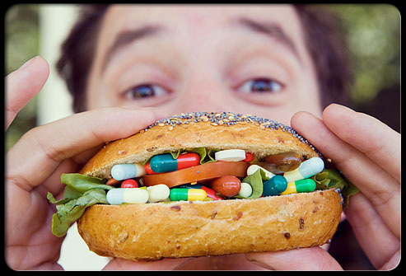

The best vitamins are really in your “Whole Foods”

If an athlete is going to take a vitamin or other supplement it needs to be evaluated.

**Evaluating a Supplement:**

1. If you are to supplement it is advisable to consult with a Nutritionist or Physician- especially someone tuned into sports medicine, athletes’ needs, and supplementation.
2. Look at labels and determine whether it is made by a nationally known food and drug manufacturer. They can be researched on-line and have good reputations. They follow a very strict quality control measure (for example, terms like “molecularly distilled” may be used) and are often willing to answer questions and complaints.
3. There are also federally funded organizations such as the USP (United States Pharmacopoeia) that performs quality tests on supplements to determine how pure it is. But remember, the FDA and USP do not evaluate all supplements and there are supplements that are excellent and have not been evaluated and supplements that are of poor quality as well. **Use your better judgment and consult with a professional!**

**Performance Enhancing Drugs**

There are athletes who have entertained the thought of taking performance enhancing drugs such as Anabolic steroids to give themselves a competitive edge. The simple truth behind this matter is that they are harming themselves physically and psychologically. Plus they are cheating which impacts other athletes around them.

**Here are some other Reasons NOT to engage in PED’s :**

**Health Risks**

"Performance enhancers, like steroids and other forms of doping, have a negative effect on long-term health. For then users of these enhancers are hurting themselves in the long run without on the average improving their short-term rewards from athletic competition, as long as competitors also use harmful enhancers. This is the main rationale for trying to ban steroids and other forms of doping from athletic competitions."

Gary Becker, PhD

Professor in the Departments of Economics, Sociology, and the Graduate School of Business at the University of Chicago

"Doping in Sports," Becker-Posner blog

Aug. 27, 2006

**Unfair Advantage**

Remember that athletes don't take these drugs to level the playing field; they do it to get an advantage. And if everyone else is doing what they're doing, then instead of taking 10 grams or 10 cc's or whatever it is, they'll take 20 or 30 or 40, and a vicious circle simply gets bigger. The end game will be an activity that is increasingly violent, extreme, and meaningless, practiced by a class of chemical and or genetic mutant gladiators. The use of performance-enhancing drugs is not accidental; it is planned and deliberate with the sole objective of getting an unfair advantage."

Richard Pound, BCL

Former President of the World Anti-Doping Agency

Intelligence Squared US debate titled "We Should Accept Performance-Enhancing Drugs in Competitive Sports," moderated by Bob Costas

Jan. 15, 2008

**Drug Testing**

The detection methods are accurate and reliable. They undergo rigorous validation prior to being introduced... WADA is, of course, keenly interested in the efficiency, as well as the effectiveness, of the global anti-doping system and supports research to help enhance testing efficiency...

Working collaboratively with national anti-doping agencies such as the U.S. Anti-Doping Agency (USADA) in the sharing of information has uncovered the designer steroid THG, and WADA-certified laboratories continue to keep a watchful eye for previously unknown doping agents...

The I.O.C. retains ownership of the athlete's samples (blood and urine) for eight years following the Olympic Games... During the ensuing eight years, if a technique is developed that would enable the detection of a prohibited substance... the stored specimen could be tested for that specific substance and the athlete would be held accountable."

Gary I. Wadler, MD

Chairman of the World Anti-Doping Agency's (WADA) Prohibited List and Methods Sub-Committee

"Dr. Gary Wadler of the World Anti-Doping Agency Gives His Answers to Your Questions (Part I)," New York Times

June 26, 2008

**Sportsmanship**

Anti-doping programs seek to preserve what is intrinsically valuable about sport. This intrinsic value is often referred to as 'the spirit of sport'; it is the essence of the Olympics; it is how we play true. The spirit of sport is the celebration of the human spirit, body and mind, and is characterized by the following values: •Ethics, fair play and honesty.

•Health.

•Excellence in performance.

•Character and education.

•Fun and joy.

•Teamwork.

•Dedication and commitment.

•Respect for rules and laws.

•Respect for self and other participants.

•Courage.

•Community and solidarity.

Doping is fundamentally contrary to the spirit of sport."

World Anti-Doping Agency (WADA)

World Anti-Doping Code

Mar. 2003

**Athletes as Role Models**

For many male high school athletes, pro athletes are major influences. They are the role models. They choose the jersey numbers of their favorite professional players. They emulate their training regimens. They emulate their style of play. And they are influenced by their drug use. When a professional athlete admits to using steroids, the message young athletes hear is not always the one that is intended. Young athletes often believe that steroid use by their role models gives them permission to use. That it is simply part of what one must do to become an elite athlete."

Greg Schwab

Testimony for the hearing "Steroid Use in Professional Baseball and Anti-Doping Issues in Amateur Sports" before the US Senate Committee on Commerce, Science, and Transportation Subcommittee on Consumer Affairs, Foreign Commerce, and Tourism

June 18, 2002

**Congratulations** on completing Dr. B’s Sports Medicine Camp! I truly hope that you got a lot out of this “Camp”?! My intention was to teach you as much as possible about this exciting field and have a lot of Fun along the way. Hopefully it accomplished both!

I hope that you continue to keep a keen interest in Sports Medicine and recognize and appreciate how informative it can be for you as well as those around you! Also, the potential impact this knowledge can have on unlimited athletes, parents, and professionals!

Enjoy your summer and if you have any questions please do not hesitate to shoot me an email referencing “sports medicine camp” and I will try to get back to you with a response in a timely fashion. My email is [Drbrightman@aol.com](mailto:Drbrightman@aol.com) : My website is www.drBrightman.com

Thank You!

Yours in Great Health!

Dr. Brightman, DC, MS, MEd